**Google Search Engine Lookalike**

### A MINI PROJECT REPORT

#### Submitted by

#### Group/Team No: G8/T15

**Kaniska Maity-2210991741**

**Kannan-2210991742**

**Kanushi Gupta-2210991743,**

**Kapil-2210991744**

#### in partial fulfillment for the award of the degree of

## BACHELEOR OF ENGINEERING

***in***

COMPUTER SCIENCE & ENGINEERING



**CHITKARA UNIVERSITY**

**CHANDIGARH-PATIALA NATIONAL HIGHWAY**

**RAJPURA (PATIALA) PUNJAB-140401 (INDIA)**

##### April & 2023

**Table Of Content**

|  |  |  |
| --- | --- | --- |
| Sr.no | Section | Page no |
| 1. | Introduction | 3 |
| 2. | Problem Statement | 4 |
| 3. | Technical Details | 5-6 |
| 4. | Code with project output | 7-17 |
| 5. | Project Advantages | 18 |
| 6. | Conclusion | 19 |

**INTRODUCTION**

**1.1 What is a google search engine**

A website designed to resemble the look and functionality of the Google search engine is known as a Google search engine look-alike. The search capabilities and features of this website are comparable to those of the original Google search engine.

Typically, the layout and design of a Google search engine look-alike is based on the original Google search interface, which emphasizes simplicity and simplicity of use. Most of the time, the main search bar is at the top of the page.

A list of links and brief descriptions of each page are typically displayed alongside the search results on a Google search engine look-alike in a manner that is analogous to Google's. Additional features like sponsored results, related searches, and suggested search terms may be included in some look-alike search engines.

While many look-alikes of the Google search engine attempt to replicate the original's functionality, others may also incorporate additional tools or features that are not available on the official Google search engine. Some look-alikes, for instance, may provide more in-depth analytics, advanced filtering options, or integration with third-party services and applications.

.

**PROBLEM STATEMENT**

**“building a replica of Google home page along with the Google logo, search icons, text box, Gmail, and image buttons”**

1. A Google page lookalike is a website or application that mimics the design and layout of the Google search engine page. This means that the page has a similar look and feel to the Google search engine, with elements such as the logo, search bar, search results, navigation bar, and footer designed to resemble the corresponding elements on the Google page.
2. Creating a Google page lookalike can be a useful approach for companies or organizations that want to improve user experience and make their website or application appear more professional. By providing users with a familiar and intuitive interface, a Google page lookalike can make their experience on your website or application more enjoyable and efficient.
3. However, it is important to note that creating a Google page lookalike can be a legal gray area. Companies need to ensure that they are not infringing on Google's intellectual property rights, such as its trademark or copyright. Therefore, it is important to create a design that is inspired by Google's interface but not a direct copy.

**TECHNICAL DETAIL**

The technical details in making a google search engine lookalike includes :

Gathering insights on software tools, internet services, relevant technical skills, etc.

Use of HTML and CSS made the making of google search eng form much easier.

[**HTML**](https://www.w3.org/html/) is the language for describing the structure of Web pages. Through HTML we can:

* Publish online documents with headings, text, tables, lists, photos, etc.
* Retrieve online information via hypertext links, at the click of a button.
* Design forms for conducting transactions with remote services, for use in searching for information, making reservations, ordering products, etc.
* Include spread-sheets, video clips, sound clips, and other applications directly in their documents

[**CSS**](https://www.w3.org/Style/CSS/)is the language for describing the presentation of Web pages, including colors, layout, and fonts. It allows one to adapt the presentation to different types of devices, such as large screens, small screens, or printers. CSS is independent of HTML and can be used with any XML-based markup language. The separation of HTML from CSS makes it easier to maintain sites, share style sheets across pages, and tailor pages to different environments.

**Javascript** is a high-level programming language that is primarily used for adding interactivity and dynamic behavior to websites. It is often embedded within HTML code and executed by web browsers. JavaScript is primarily used on the client-side, meaning it runs on the user's web browser. It allows developers to create interactive web pages by manipulating the Document Object Model (DOM) and responding to user events such as clicks, form submissions, and mouse movements.

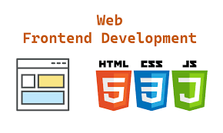

**Project code and output**

**OUTPUT**

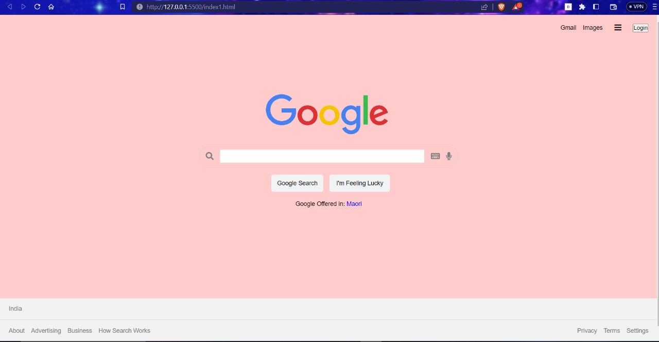

**Html code:**

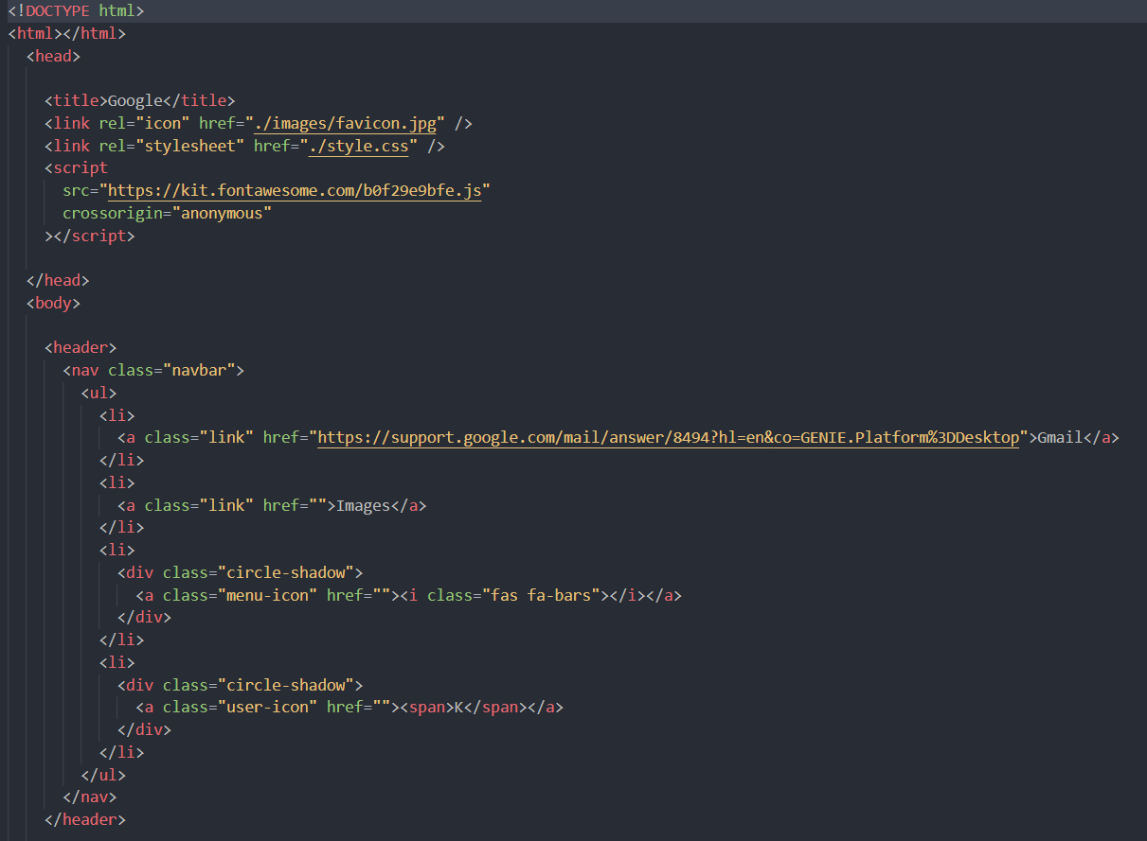

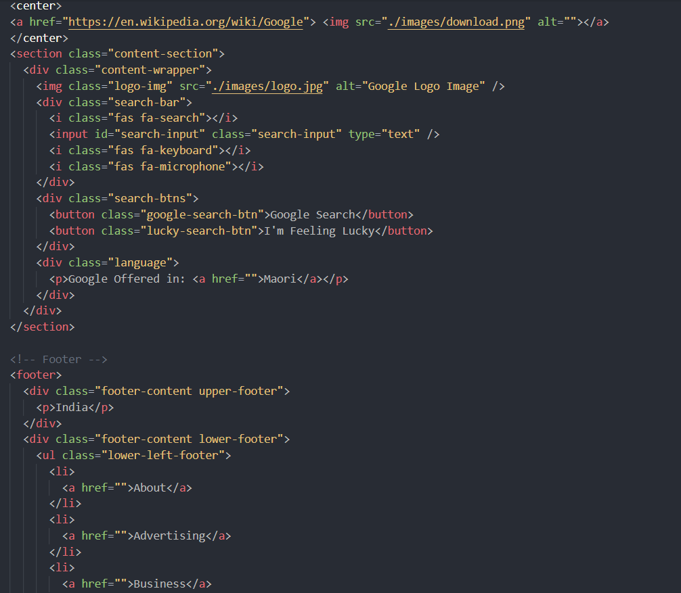

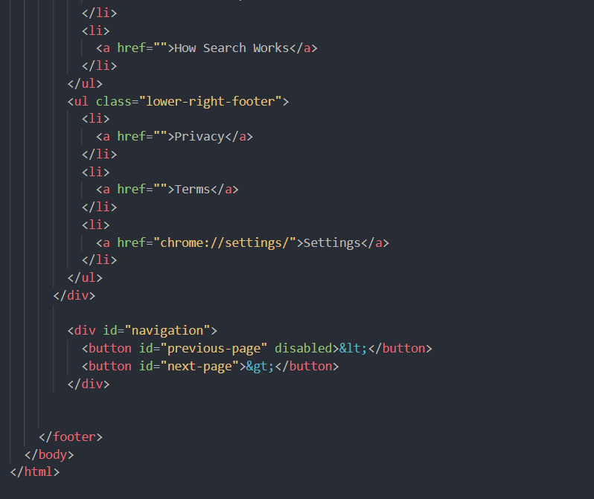

**Css code:**

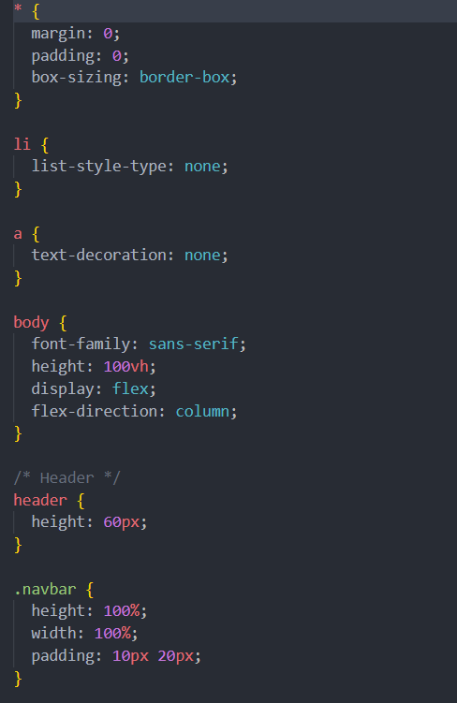

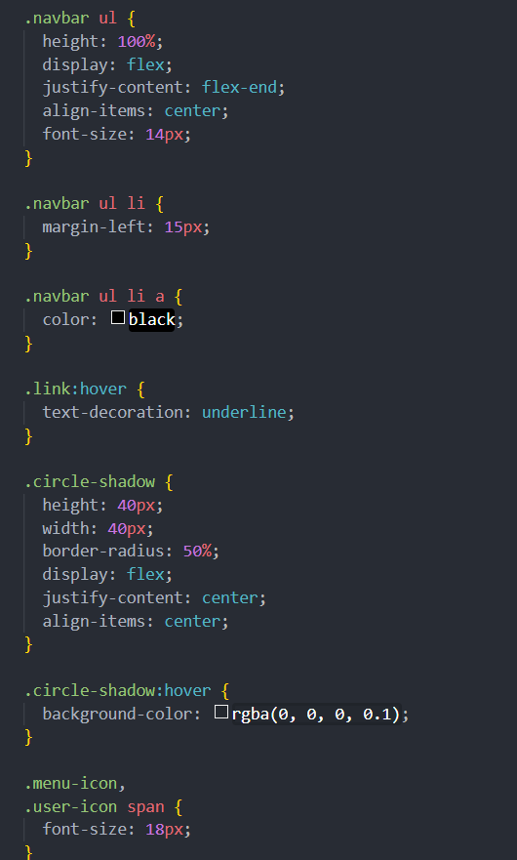

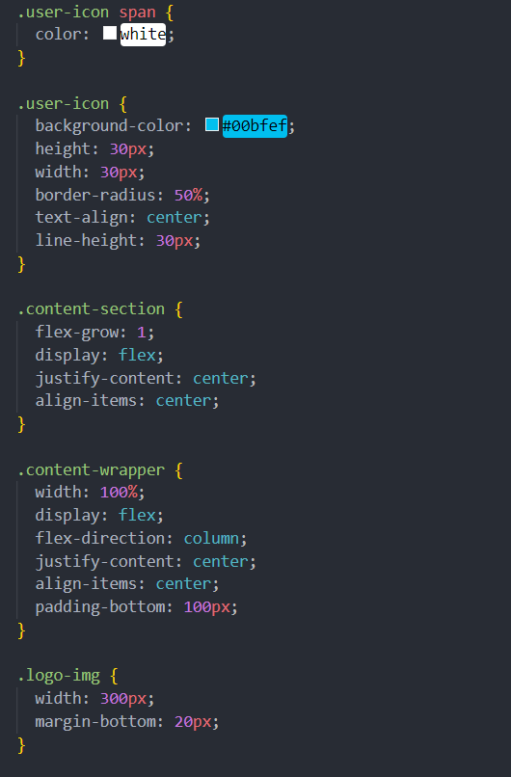

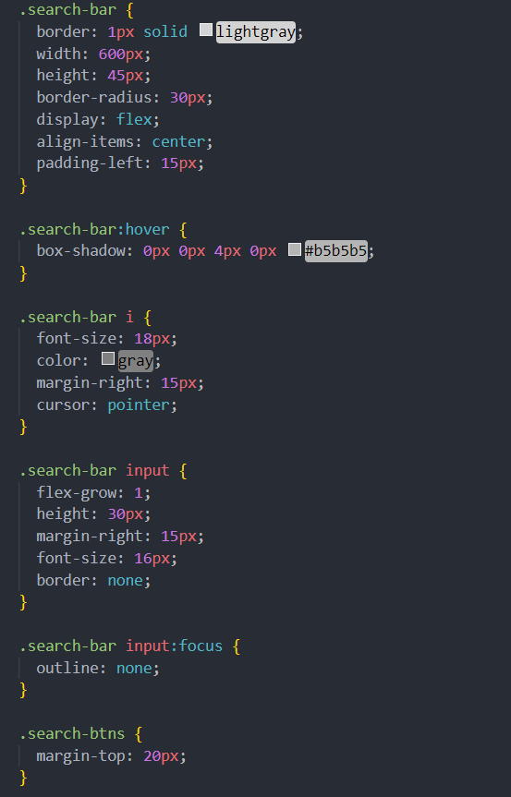

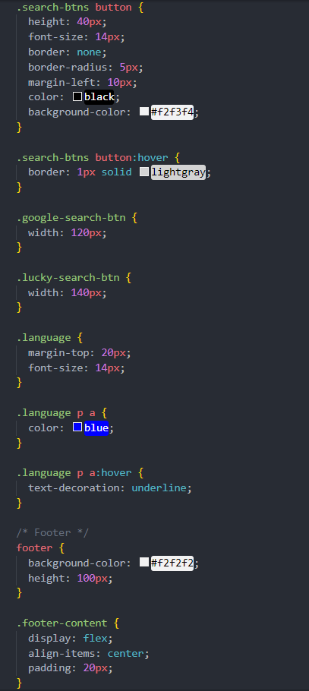

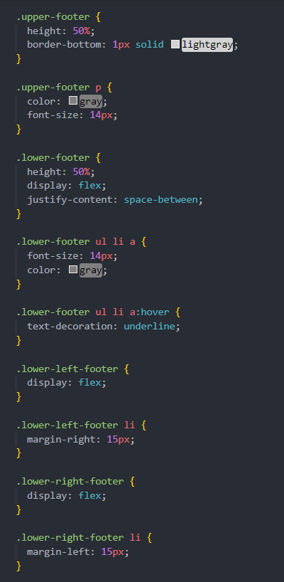

**Javascript code:**

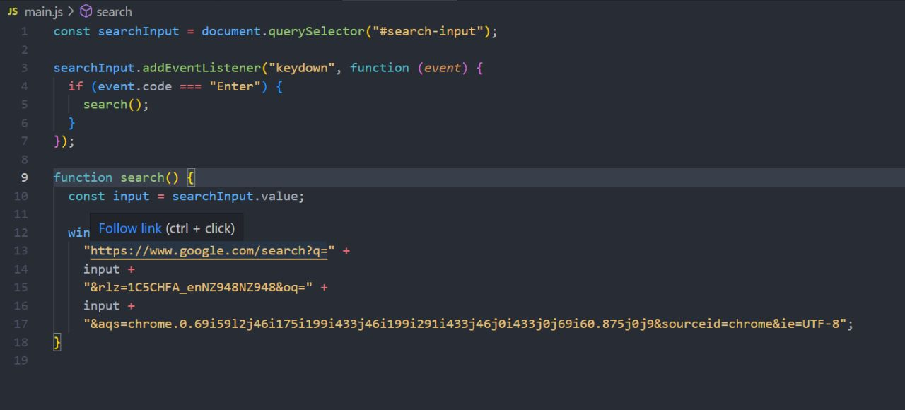

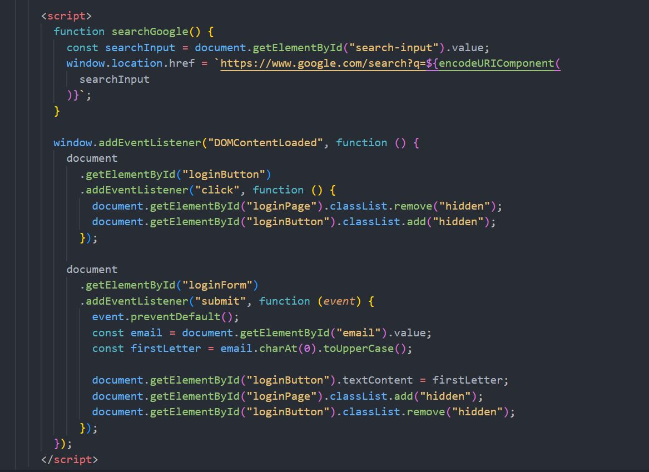

**For mobile and tablet screen**

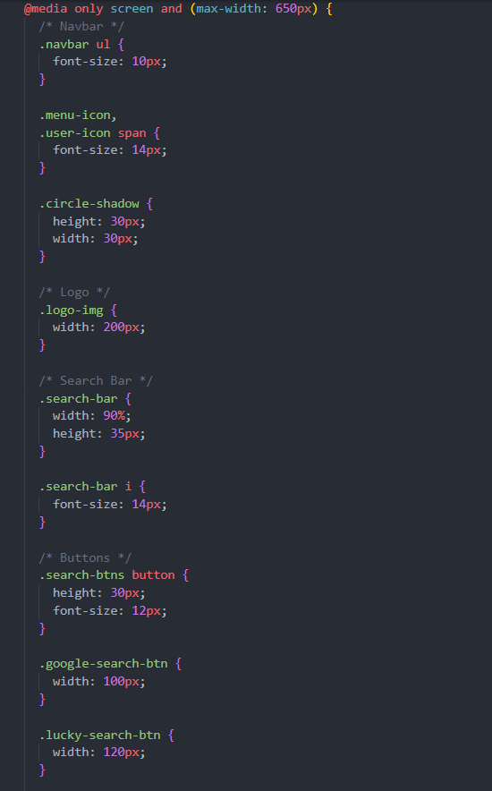

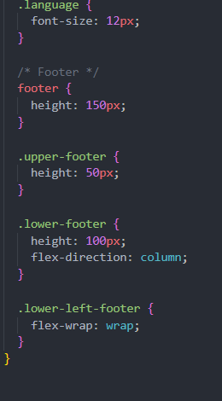

**PROJECT ADVANTAGES**

There are a few advantages to using a Google search engine lookalike over the actual Google search engine:

1. Privacy: Many people are concerned about the amount of data that Google collects on its users. By using a Google search engine lookalike, users can avoid sharing their search history and other personal information with Google.
2. Customization: Some Google search engine lookalikes offer greater customization options than Google itself. For example, some lookalikes may allow users to filter search results more precisely or to configure their search settings in a way that better suits their needs.
3. Diversity: By using a Google search engine lookalike, users can access a wider variety of search engines and search algorithms. This can help them find information that they might not be able to find using Google alone.
4. Innovation: Some Google search engine lookalikes are developed by smaller companies or individuals who may be nimbler and more innovative than Google itself. These developers may be able to introduce new features or search algorithms that are not available on Google.
5. Avoiding censorship: In some countries, Google is heavily censored or blocked entirely. By using a Google search engine lookalike, users in these countries can still access the internet and find information that may be otherwise unavailable.

Overall, while there are some advantages to using a Google search engine lookalike, it's worth noting that Google is still the most popular and widely used search engine in the world. As such, many people may prefer to use it for its reliability and familiarity.

**CONCLUSION**

Search engines offer users vast and impressive amounts of information, available with a speed and convenience few people could have imagined one decade ago. Their capabilities are expanding practically by the day. Soon it will seem routine to be able to search the contents of vast libraries of books; to find selected portions of video streams or audio recordings; to benefit from personalized searches that remember a user’s preferences and keep track of changing geographical locations. Audio searching and search results will be available for the blind; “implicit searching” will anticipate users’ queries and have answers ready.

Today’s internet users are very positive about what search engines already do, and they feel good about their experiences when searching the internet. They say they are comfortable and confident as searchers and are satisfied with the results they find. They trust search engines to be fair and unbiased in returning results. And yet, people know little about how engines operate, or about the financial tensions that play into how engines perform their searches and how they present their search results. Furthermore, searchers largely don’t notice or understand or discern the different kinds of search results that are being served up to them.